PORTFOLIO DOCUMENTATION

I created a portfolio on myself. It is hosted on Github and I have provided the link. (<https://isen-kun.github.io/Web-Dev/Portfolio/index.html>).

* It is w3 validated.

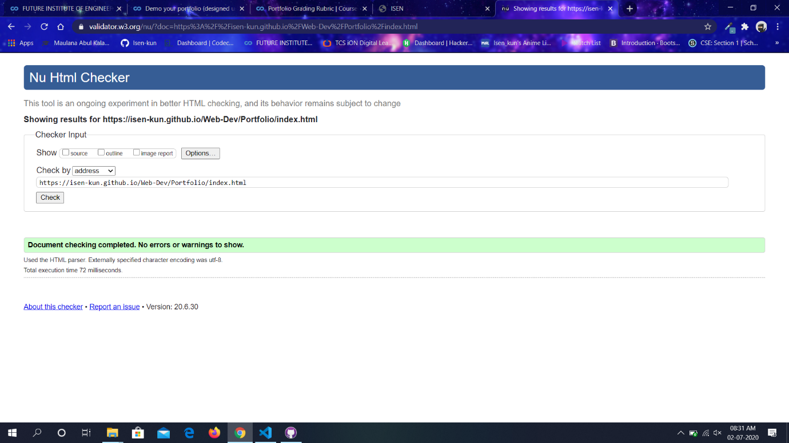

* It is responsive

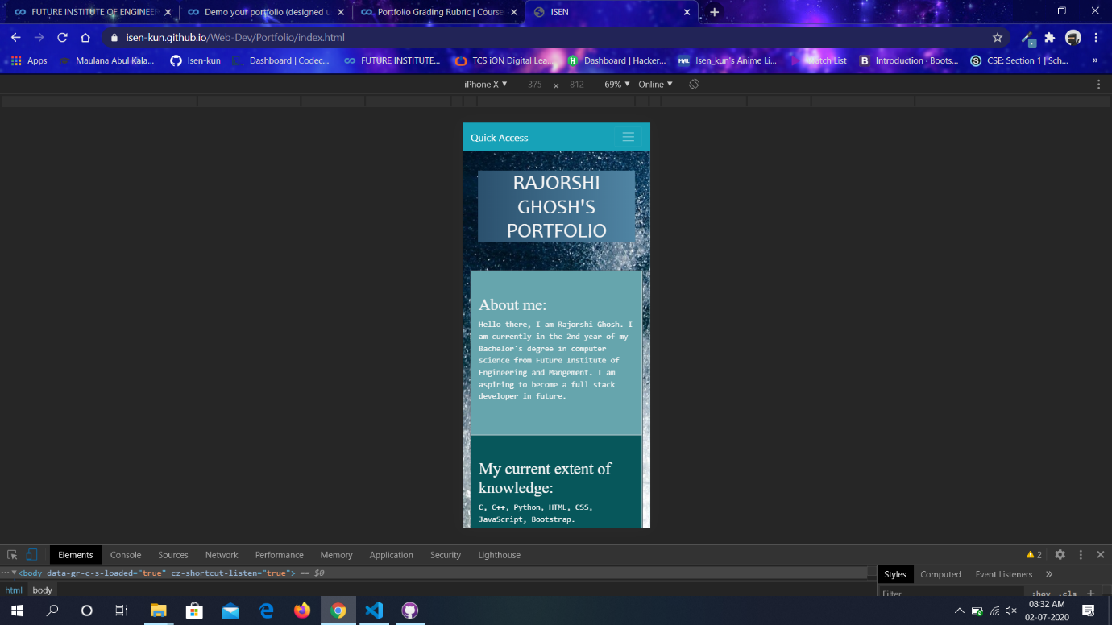

* It is well styled

body{

*background-image*: url("../images/waves.jpg");

*background-color*: #C4DFE6;

}

#mycontainer{

*padding-left*: 8%;

*padding-right*: 8%;

}

#about{

*background-color*: #66A5AD;

}

#know{

*background-color*: #07575B;

}

#certi{

*background-color*: #003B46;

}

#projects{

*background-color*: #1995ad

}

#cont{

*background-color*: #002930;

}

#about, #know, #certi, #cont, #projects, #top{

*color*: whitesmoke;

}

h1{

*background-image*: linear-gradient(to right,#2B506D, #5085A4);

*font-family*: candara, sans-serif;

*text-transform*: uppercase;

}

h2, h3{

*font-family*: 'Times New Roman', Times, serif;

}

p{

*font-family*: monospace;

*font-size*: large;

}

* It has a carousel

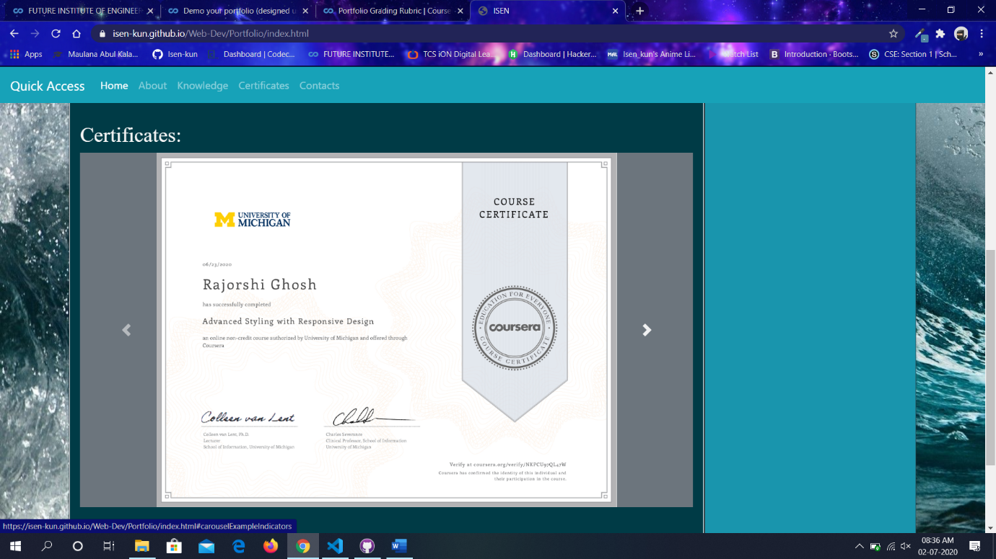

* Lots of custom JS (in my linked project)

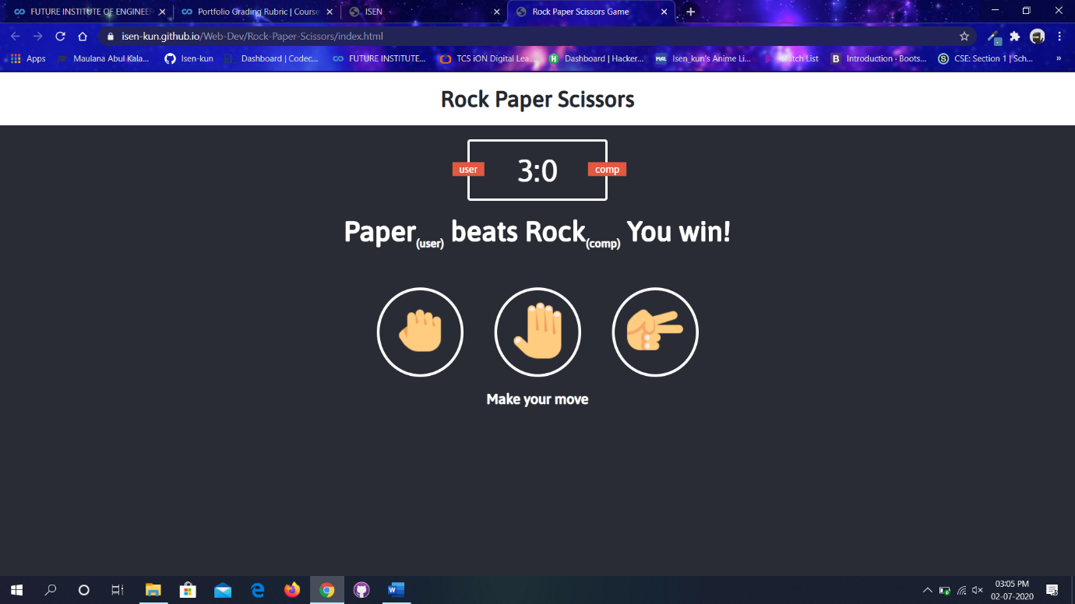

* Incorporated Google calendar with tweaks in design and placing

